# SAP Scripts

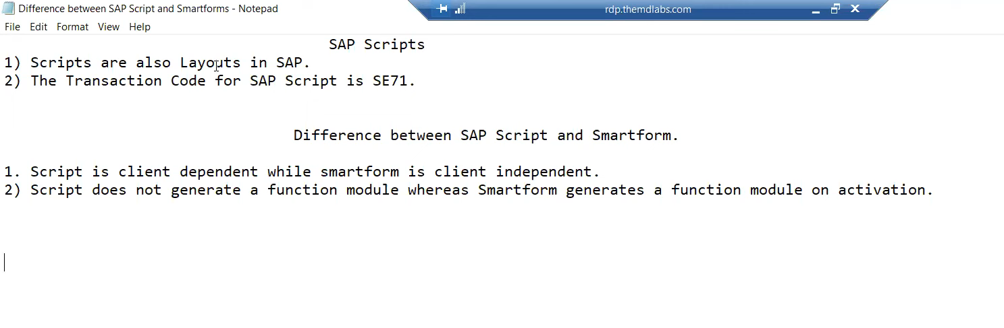

Figure SAP Scripts basic.

**It is mostly used in FI.**

Figure Requirement using sap Scripts.

## Understanding the Basic difference.

100 clients we do development.

200 clients we do testing.

Once we develop the SAP script for 100 clients it will be dependent on the client number, it will not be available for 200 clients.

In case we want to test it in client 200, we need to make a copy of sap scripts in 200 client using tcode .

SCC1 (Client copy)

## The Tcode for SAP Scripts is **SE71**

## Creating SAP Scripts.

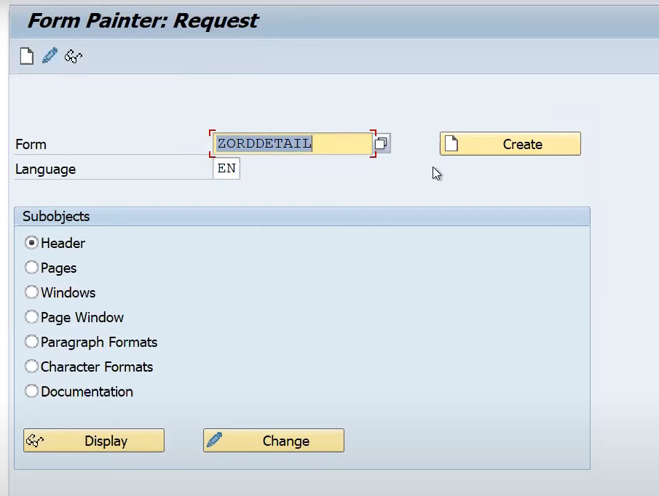

Figure Creating SAP Scripts.

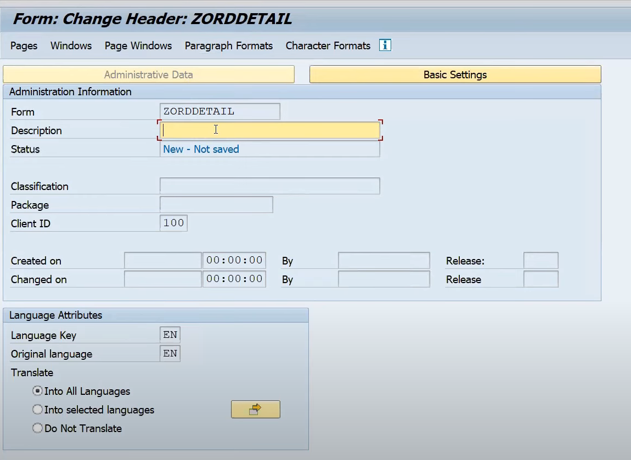

Figure Giving Description to Script.

Whenever we want to do copy of sap scripts in another client we need to save it in package and transport request

## Interview Questions

SAP Scripts is client-dependent and Smartform is client-independent.